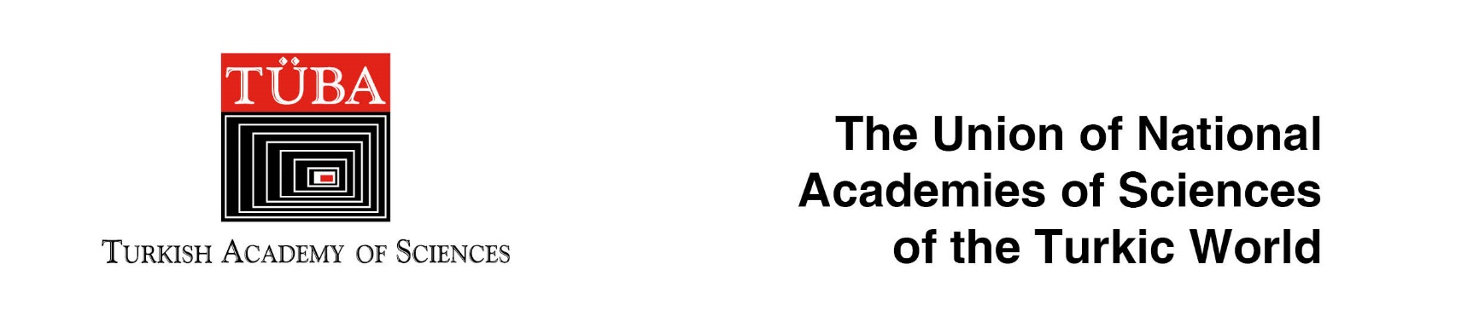

SUMMER SCHOOL on
“INTERNATIONAL LAW, DIPLOMACY AND COOPERATION”

16-20 JULY 2018
Kastamonu, TURKEY

jointly organized by

The Union of National Academies of Sciences of the Turkic World
&
Turkish Academy of Sciences

About the Organizers:
The Union of National Academies of Sciences of the Turkic World was established on June 29, 2015 on the initiative of the International Turkic Academy in accordance with the decision of the Council of Ministers of Education held in Baku on November 24, 2014. The first meeting of the Union of National Academies of Sciences of the Turkic World was held in Astana with the participation of heads of Academies of Sciences of Azerbaijan, Kazakhstan, Kyrgyzstan, Turkey, International Turkic Academy, Bashkortostan and Tatarstan. The Secretariat of the Union of National Academies of Sciences of the Turkic World was entrusted to the International Turkic Academy.
Theme:
A Summer School on “International Law, Diplomacy and Cooperation” will be held in Kastamonu (2018 Cultural Capital of the Turkic World) between 16-20 July 2018. The aim of the summer school is to promote further cooperation and close relations among the Turkic World states and peoples. To this end amongst others, themes to be touched will be:
- Fundamentals of international legal order
- Cooperation in the fields of technology, development and the environment
- Science diplomacy and international scientific collaboration
- Friendly settlement of disputes
- International organizations and cooperation
- Regional issues

Program Format:
The summer school will consist of daily lectures and onsite visits to various places of interest in Kastamonu.
Venue:
The summer school will be held at the premises of the Kastamonu University (Bilgehan Bilgili Merkez Kütüphanesi Konferans Salonu). The Summer School will take full advantage of the unique opportunities offered by this venue, embedding the academic program within the historical and natural beauty of Kastamonu.
Tutors:
The lectures will be delivered by a group of internationally renowned academics. The final program will be sent to the participants directly in June.
Participants:
The summer school is intended to be for early career professionals from both public and private sectors, graduate students and junior academics with a background especially in social sciences. At the closing ceremony, special certificates will be awarded to the participants.
Fee:
Thanks to the generous support by TÜBA and other supporters the summer school will be free of charge for 2-3 participants nominated by the member and related academies of the Union of National Academies of Sciences of the Turkic World and other invited institutions. Travel and accommodation expenses will also be provided by TÜBA.
For Enquiries and Application:
Applicants will be asked to submit the application form attached and return the form together with Curriculum Vitae, letter of motivation describing their purpose in attending the Summer School and a letter of reference. Criteria for applications are that participants should have a good basis in a discipline of social sciences (broadly defined) and good command of the English language. Nominations will be forwarded to the organizers by national academies and invited institutions directly.
The deadline for applications and nominations is 9 of June 2018.

For enquiries please contact: summerschool@tuba.gov.tr

